Total mark /5

**Pearson 10: Accelerating Masses practical**

*Note: This is an assessment item worth 5% of your grade. It is possible for you to perform this experiment online without equipment.*

Step 1: Watch the “Accelerating masses Demo” video ([https://youtu.be/UQtNKS-g1uM](https://aus01.safelinks.protection.outlook.com/?url=https%3A%2F%2Fyoutu.be%2FUQtNKS-g1uM&data=02%7C01%7Cmatthew.paton2%40education.wa.edu.au%7Cd40b703075ff440b8c2f08d7d219c826%7Ce08016f9d1fd4cbb83b0b76eb4361627%7C0%7C0%7C637208880482084151&sdata=E0ncxnFIApWkVy1F6%2B4eW6c3DaHZnCfqmip1R494Qp8%3D&reserved=0)) to get an overall understanding of what happens.

1) What safety issues can you observe in the video? Are there any ways to prevent injury or damage to equipment? (1 mark)

__________________________________________________________________________________

__________________________________________________________________________________

__________________________________________________________________________________

__________________________________________________________________________________

Step 2: Read the “Pearson 10 page 277 Lab - Accelerating masses” document to enhance your understanding of the experiment.

2) The equipment to measure acceleration was listed as a stopwatch and a ruler, light gates for data-logging **OR** ticker timer and ticker tape. Which of the three equipment sets would be the most suitable for this experiment? Why? (There is no wrong answer as long as you justify it) (1 mark) __________________________________________________________________________________

__________________________________________________________________________________

__________________________________________________________________________________

__________________________________________________________________________________

Step 3: Look at the following results table. Is there anything that you would change? Would you do fewer trials or more trials? Each slotted mass in the hanging masses is 50g. Would you make any changes to your hanging masses?

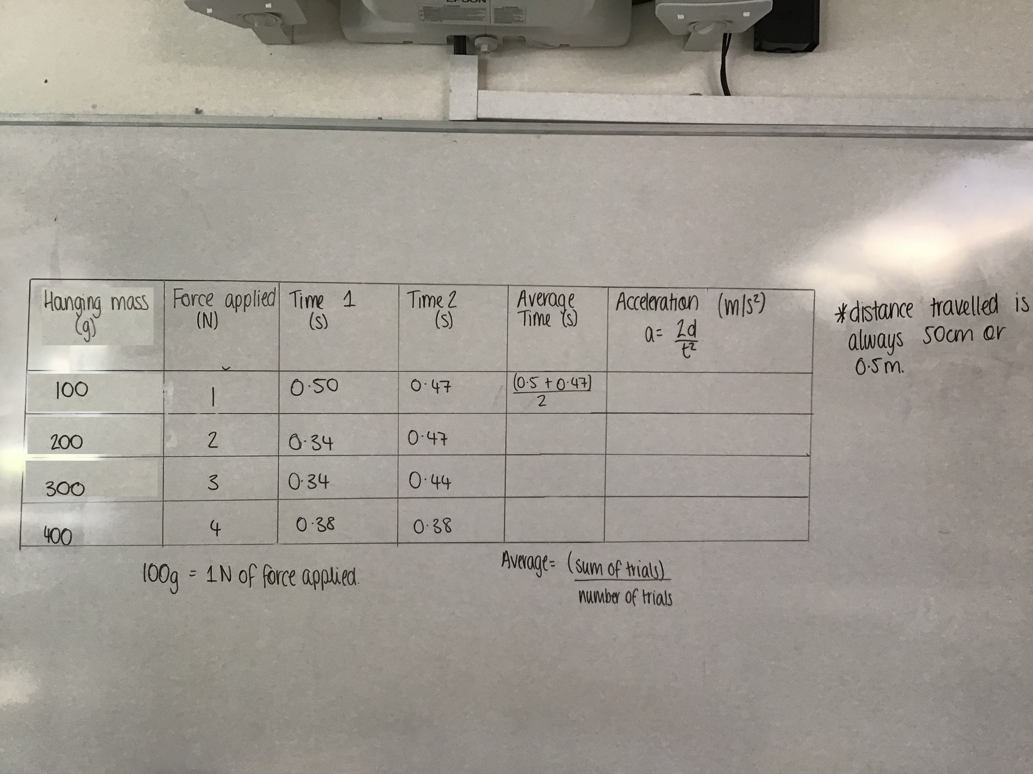

How would you change the above, if anything? (1 mark)

__________________________________________________________________________________

__________________________________________________________________________________

__________________________________________________________________________________

Step 4:

Re-draw the table on paper **OR** on Microsoft word and complete the results using a calculator. (1 mark)

Step 5: What would be the best way to represent the data? What should be on the x and y axis? What is the best graph type to use? (1 mark)

__________________________________________________________________________________

__________________________________________________________________________________

__________________________________________________________________________________

__________________________________________________________________________________

__________________________________________________________________________________

__________________________________________________________________________________

__________________________________________________________________________________

__________________________________________________________________________________

__________________________________________________________________________________